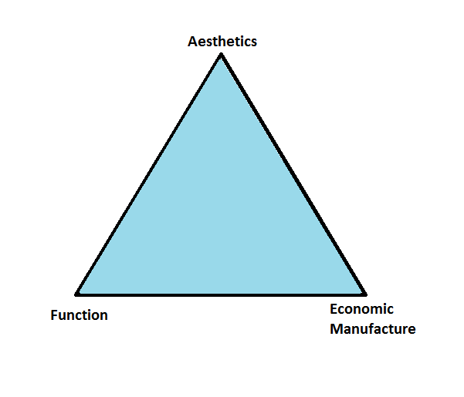

**Topic 2.2.1 Product**

**Core Knowledge**

The **design mix** is a diagram to show how a business   
must consider the aesthetics and function of a product  
as well as the cost.

When creating a product a business will want it to  
stand out from rivals. This is known as **product  
differentiation**. Businesses can use **branding** or **USPs**.

The **Product life cycle** shows the stage that every product goes through. A business will use **extension strategies** to extend the life cycle.

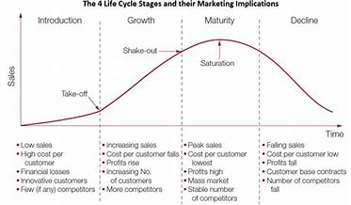

**Don’t be a “man on the street”**

* Don’t assume everyone prefers branded products – some   
  consumers will consider cost more important
* Remember that all products will see a decline in sales, eventually, but the time this takes will differ
* Just because a product is in decline does not mean it must be withdrawn – it may still contribute a considerable amount of revenue

**Synoptic Links**

**Customer needs** – if these change products will need to change

**Market research** – how a business finds out customer needs

**External influences** – will lead to changes in 4Ps

**Operations** – need to be able to make the product

**Breakeven** – understanding the link between costs and economic viability

**Wider Business World**

**Apple –** use of branding and extension strategies

**Kellogg’s** – developed new products such as cereal bars to meet customer needs

**KitKat** – launched different flavours and sizes as an extension strategy

**BUSINESS**: ***Creating informed, discerning employees, consumers and future leaders***

**Key Vocabulary**

**Design mix** – the combination of aesthetics, function and cost that are the combined design priorities for a product

**Aesthetics** – how things appeal to the senses, i.e. look, smell, sound

**Function** – how well the product or service works for the consumer

**Economic manufacture** – making a product cheaply enough to make it profitable

**Product life cycle** – the theory that every product goes through the same stages

**Introduction phase** – phase of the product life cycle when a product is developed and launched onto the market

**Growth phase** – phase of the product life cycle where sales are growing; costs will be very high

**Maturity phase** – phase where sales and revenue is at the highest point

**Decline phase** – phase when sales are dropping

**Extension strategy** – an attempt to prolong sales of a product to avoid the decline phase

**Product differentiation** – the extent to which consumers see your product as distinct from rivals