

**Topic 2.3.2 Working with suppliers**

**Core Knowledge**

The operations department has a role to ensure that there is enough stock to meet demand, so they must work closely with suppliers as well as managing the stock that is in the business effectively.

The amount of stock held is shown in a bar gate graph:

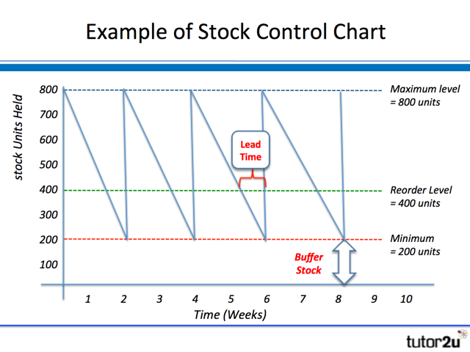

|  |  |
| --- | --- |
| **Benefits of JIT** | **Limitations of JIT** |
| Less storage space needed saving costs  Fresher produce due to more frequent deliveries  Less capital tied up in stock | Greater risk of running out and disappointing customers  No bulk-buying discounts |

**Don’t be a “man on the street”**

* Remember not all business that hold stock are shops – it could be  
  a factory, restaurant, bakery
* The cheapest supplier may not be the best if they are not reliable
* Not all businesses will be able to get trade credit from a supplier – trust may need to built first

**Synoptic Links**

**Cashflow –** holding less stock improves cashflow because the stock is more likely to be sold before payment to suppliers is due

**External factors** – changes to economic factors can affect the type of products consumers demand

**Customer needs** – if quality is a concern more than price, this will need to be considered when choosing a supplier

**Location** – this could affect the logistics for a business

**Wider Business World**

**Supermarkets –** most run JIT systems to have more selling space and save costs on storage

**Restaurants** – may limit their menu choices to ensure ingredients are fresher and less stock is wasted

**BUSINESS**: ***Creating informed, discerning employees, consumers and future leaders***

**Key Vocabulary**

**Stock** – items held by a firm for use or sale. Also called inventory

**Bar gate stock graph** – a diagram to show changes in the level of stock over time

**Maximum** **stock** **level** – highest level of stock to be held by a business

**Minimum stock level** – also called buffer stock level. The lowest level of held to avoid running out

**Re-order level** – the level of stock that will trigger the business to order more

**Lead** **time** – number of days or weeks that it takes from ordering stock until it arrives

**Order** **quantity** – the number of items ordered by the business

**JIT** – Just in Time. Running the business with so little stock that supplies have to arrive ‘just in time’ before they run out

**JIC** – holding buffer stock levels, ‘just in case’ there is a sudden increase in demand

**Procurement** – obtaining the right supplies from the right supplier

**Logistics** – ensuring that the right supplies will be ordered and delivered on time